TRIPURA AND KERALA DATA ANALYSIS USING R:

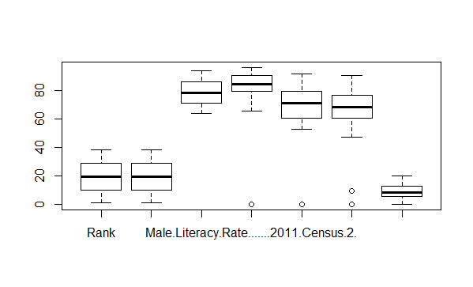

BOXPLOT OF LITERACY RATE OF TRIPURA

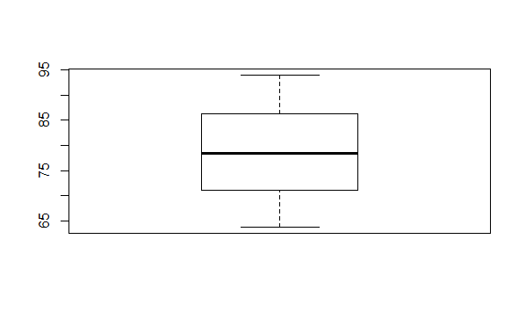

BOXPLOT 2011 LITERACY

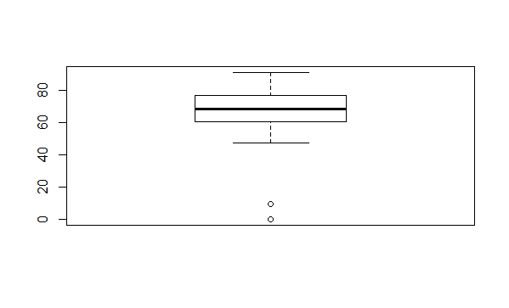

BOXPLOT 2001 LITERACY

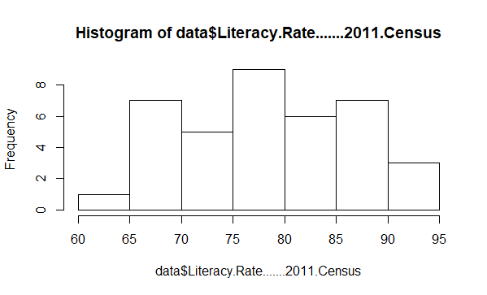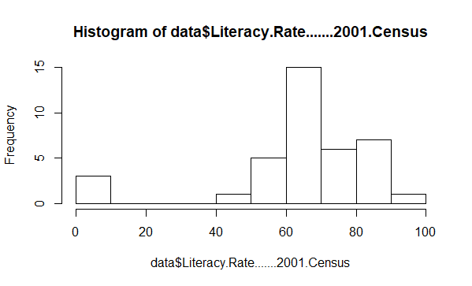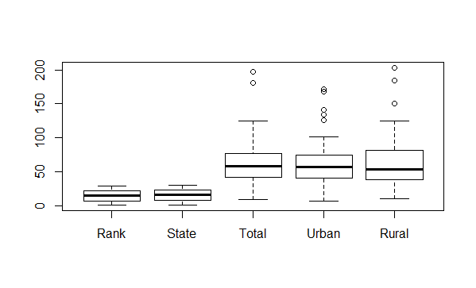

UNEMPLOYMENT RATE BOXLPOT

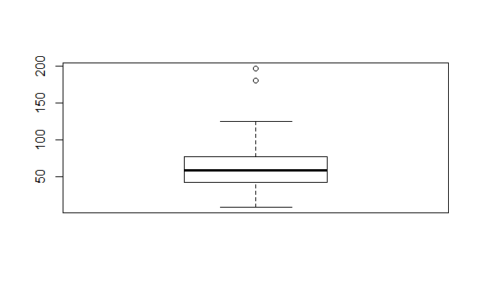

TOTAL BOXPLOT OF UNEMPLOYED

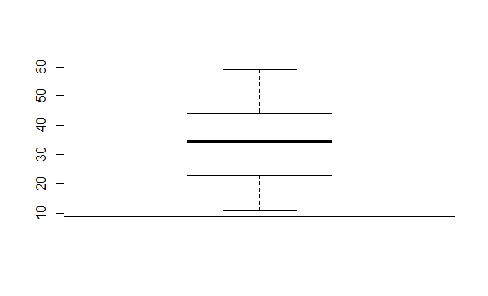

INFANT MORTALITY RATE 2011

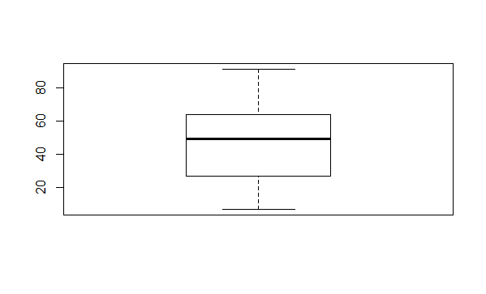

INFANT MORTALITY RATE 2001

ANALYSIS:   
from the following analysis and sources (mentioned at last but not sufficient)

The following information can be extracted:

* Although some sources(no dataset available) claim that Tripura after a jump of literacy rate has become state with highest rate following Kerala it may be wrong
* Some sources cite that fake educational certificates and undeserved teachers and graduates have become one of the main reasons for high education rate but low employment. This is primarily due to judgement of multinational companies to not accept such frauds.
* Secondly, infant mortality rate has reduced in Tripura which obviously will have an impact on total population and ultimately on literacy rate.
* Due to boom in population even if the educational demands are met job demands are not met due to high poverty, low percapita income and less development in industrial sector.
* One of the reasons for this situation is because of communism and government which does not let the industrial sector expand(this is found to be common for both Kerala)
* Violence and crime rate for both Tripura have also been a factor for low employment rates.

NOTE: if more appropriate datasets and links would have been provided, better information with the use of numbers could’ve been extracted

SOURCES:

<https://en.wikipedia.org/wiki/Tripura#Education>

data=https://en.wikipedia.org/wiki/List_of_Indian_states_and_union_territories_by_literacy_rate#cite_note-6

data2=https://en.wikipedia.org/wiki/List_of_states_and_union_territories_of_India_by_unemployment_rate

data3=<http://niti.gov.in/content/infant-mortality-rate-imr-1000-live-births>

<https://www.google.co.in/search?q=fake+education+tripura&rlz=1C1CHBF_enIN757IN757&oq=fake+education+tripura&aqs=chrome..69i57.13746j0j7&sourceid=chrome&ie=UTF-8>

<https://www.thequint.com/news/politics/tripura-is-low-on-development-high-on-social-health-indices>

<https://data.gov.in/dataset-group-name/crime-statistics>

CODE:

> data <- read.delim("C:/Users/Gideon 3.0/Desktop/data.txt")

> View(data)

> data2 <- read.delim("C:/Users/Gideon 3.0/Desktop/data2.txt")

> View(data2)

> summary(data$Literacy.Rate.......2011.Census)

Min. 1st Qu. Median Mean 3rd Qu. Max.

63.82 71.58 78.48 78.29 85.65 93.91

> summary(data$Literacy.Rate.......2001.Census)

Min. 1st Qu. Median Mean 3rd Qu. Max.

0.00 60.95 68.28 64.41 76.78 90.86

> summary(data$Decadal.Difference..pp.)

Min. 1st Qu. Median Mean 3rd Qu. Max. NA's

0.000 5.620 8.440 8.666 12.610 20.020 1

> summary(data2$Total)

Min. 1st Qu. Median Mean 3rd Qu. Max.

9.00 42.25 58.50 65.70 76.25 197.00

> boxplot(data)

> library(psych)

> describe(data$Literacy.Rate.......2011.Census)

vars n mean sd median trimmed mad min max range skew kurtosis se

X1 1 38 78.29 8.09 78.48 78.13 11.29 63.82 93.91 30.09 0.05 -1.08 1.31

> describe(data$Literacy.Rate.......2001.Census)

vars n mean sd median trimmed mad min max range skew kurtosis se

X1 1 38 64.41 20.92 68.28 67.88 12.46 0 90.86 90.86 -1.82 3.25 3.39

> boxplot(data$Literacy.Rate.......2011.Census)

> boxplot(data$Literacy.Rate.......2001.Census)

> hist(data$Literacy.Rate.......2011.Census)

> hist(data$Literacy.Rate.......2001.Census)

> boxplot(data2)

> boxplot(data2$Total)

> data3 <- read.delim("C:/Users/Gideon 3.0/Desktop/data3.txt")

> View(data3)

> describe(data3$X2011)

vars n mean sd median trimmed mad min max range skew kurtosis se

X1 1 36 34.17 13.59 34.5 34.1 14.83 11 59 48 0.14 -1.02 2.27

> describe(data3$X2001)

vars n mean sd median trimmed mad min max range skew kurtosis se

X1 1 35 47.26 24.25 49 47.24 25.2 7 91 84 -0.12 -1.09 4.1

> boxplot(data3$X2011)

> boxplot(data3$X2001)

**************************USED ON RSTUDIO******************************************************